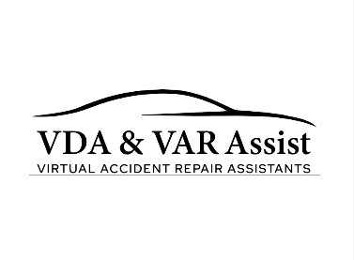
VDA & VAR ASSIST LTD – PRIVACY NOTICE
Last Updated: 15 January 2026
VDA & VAR Assist Ltd (“we”, “us”, or “our”) is committed to protecting the privacy and security of personal data. This Privacy Notice explains how we collect, process and protect personal information in accordance with UK GDPR, the Data Protection Act 2018 and the Data (Use and Access) Act 2025.

1. Data Controller & Contact Details
VDA & VAR Assist Ltd is the Data Controller responsible for the personal data we process.
Company Number: 16942969
Registered Office: Suite 9 Swallow Court, Devonshire Gate, Tiverton, Devon EX16 7EJ
Data Privacy Lead: Managing Director
Email: info@varassist.co.uk
Telephone: 07340 752956
The company is registered with the Information Commissioner’s Office (ICO).

2. Information We Collect
We collect information necessary to provide our services including vehicle damage assessments, estimate reviews, operational support and administrative services.
Identity & Contact Data – name, business name, address, email and telephone numbers.
Vehicle & Claim Data – vehicle registration (VRM), VIN, mileage, damage images and claim numbers.
Financial Data – invoices, account information and order references.
Website Data – information submitted through website enquiry forms or booking tools.

3. Legal Basis for Processing
We process personal data under the following lawful bases:
Contract – where processing is necessary to provide services requested by the client.
Legitimate Interests – where processing is required to operate our business and respond to enquiries.
Legal Obligations – where records must be retained to comply with UK law such as HMRC requirements.

4. Systems & Data Processors
We use trusted third‑party systems that may process information securely on our behalf including:
Audatex – vehicle damage estimating system.
Wix – website hosting and enquiry forms.
QuickBooks – accounting and invoicing platform.
These providers act as data processors and process information in accordance with their own privacy policies and applicable data protection legislation.

5. Automated Decision‑Making
We do not rely on automated decision‑making. All technical assessments are reviewed and verified by qualified ATA Vehicle Damage Assessors.

6. Data Retention
We retain data only as long as necessary to fulfil legal and professional obligations.
Accounting records – retained for 6 years plus the current financial year.
Technical assessments – retained for up to 6 years for legal limitation purposes.
Website enquiries – retained for up to 2 years from the last interaction.

7. International Data Transfers
Some service providers may process data outside the United Kingdom. Where this occurs appropriate safeguards are implemented to protect personal data in accordance with UK GDPR.

8. Your Rights
Under UK data protection law you have the right to access, correct, erase, restrict or object to the processing of your personal data.

9. Complaints
If you have concerns about how your data is handled, please contact us first at info@varassist.co.uk. If you remain dissatisfied you may contact the Information Commissioner’s Office (ICO) at www.ico.org.uk or telephone 0303 123 1113.
VDA & VAR Assist Ltd | Company No: 16942969
Registered Office: Suite 9 Swallow Court, Devonshire Gate, Tiverton, Devon EX16 7EJ
www.varassist.co.uk

