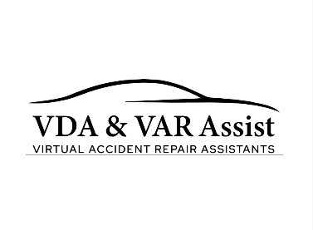
VDA & VAR Assist Ltd – Cookie Policy
Last Updated: 12TH March 2026
This Cookie Policy explains how VDA & VAR Assist Ltd (“we”, “us”, or “our”) uses cookies and similar technologies on www.varassist.co.uk.

What Are Cookies?
Cookies are small text files placed on your device when you visit our website. They help us provide, protect and improve our services.

Types of Cookies We Use
Essential Cookies – Required for website functionality including security, login systems and booking forms.
Analytics Cookies – Help us understand how visitors use our website including page views, time spent and device type. Our website uses Wix analytics tools.
Preference Cookies – Remember your settings and preferences such as language or region.
Marketing Cookies – Where used, these may track activity for advertising or marketing purposes such as Google Analytics or similar services.

Managing Cookies
You can manage or delete cookies through your browser settings. For more information visit www.allaboutcookies.org.

Consent
When you visit our website you will be presented with a cookie consent banner. You may accept or decline non-essential cookies at any time.

Third‑Party Cookies
Some cookies may be set by third‑party providers such as Wix or analytics services. Please refer to their privacy policies for further details.

Changes to This Policy
We may update this Cookie Policy from time to time. The latest version will always be available on this page.

Contact
If you have questions about this Cookie Policy, please contact:
VDA & VAR Assist Ltd
Email: info@varassist.co.uk
Telephone: 07340 752956
VDA & VAR Assist Ltd | Company No: 16942969
Registered Office: Suite 9 Swallow Court, Devonshire Gate, Tiverton, Devon EX16 7EJ
www.varassist.co.uk

