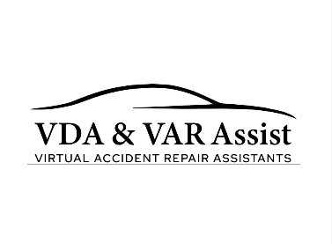
VDA & VAR ASSIST LTD – WEBSITE TERMS OF USE
Last Updated: 15 January 2026
These Website Terms of Use govern access to and use of the website www.varassist.co.uk operated by VDA & VAR Assist Ltd. By accessing or using this website you agree to be bound by these Terms of Use. If you do not agree with these terms, you should not use this website.

1. Company Information
VDA & VAR Assist Ltd
Company Number: 16942969
Registered Office: Suite 9 Swallow Court, Devonshire Gate, Tiverton, Devon EX16 7EJ
Email: info@varassist.co.uk
Telephone: 07340 752956

2. Website Use
This website is provided for general information about the services offered by VDA & VAR Assist Ltd. Users agree to use this website only for lawful purposes and in a way that does not infringe the rights of, restrict, or inhibit the use of this website by any other person.

3. Intellectual Property
All content on this website including text, graphics, logos, documents, and service descriptions is the property of VDA & VAR Assist Ltd unless otherwise stated. Content may not be copied, reproduced, republished, or distributed without prior written permission.

4. Website Content Disclaimer
Information provided on this website is for general information purposes only. While we aim to ensure that the information provided is accurate and up to date, VDA & VAR Assist Ltd makes no guarantees regarding the completeness, accuracy or reliability of the information.

5. Limitation of Liability
VDA & VAR Assist Ltd shall not be liable for any loss or damage arising from use of this website or reliance on information contained within it, including but not limited to indirect or consequential loss.

6. External Links
This website may contain links to third-party websites. These links are provided for convenience only. VDA & VAR Assist Ltd has no control over and accepts no responsibility for the content or privacy practices of external websites.

7. Website Availability
We do not guarantee that the website will always be available or uninterrupted. We may suspend, withdraw or change any part of the website without notice.

8. Changes to These Terms
VDA & VAR Assist Ltd may update these Website Terms of Use from time to time. The latest version will always be available on this page.

9. Governing Law
These Terms of Use are governed by the laws of England and Wales. Any disputes arising in connection with the use of this website shall be subject to the jurisdiction of the courts of England and Wales.
VDA & VAR Assist Ltd | Company No: 16942969
Registered Office: Suite 9 Swallow Court, Devonshire Gate, Tiverton, Devon EX16 7EJ
Email: info@varassist.co.uk | Web: www.varassist.co.uk

